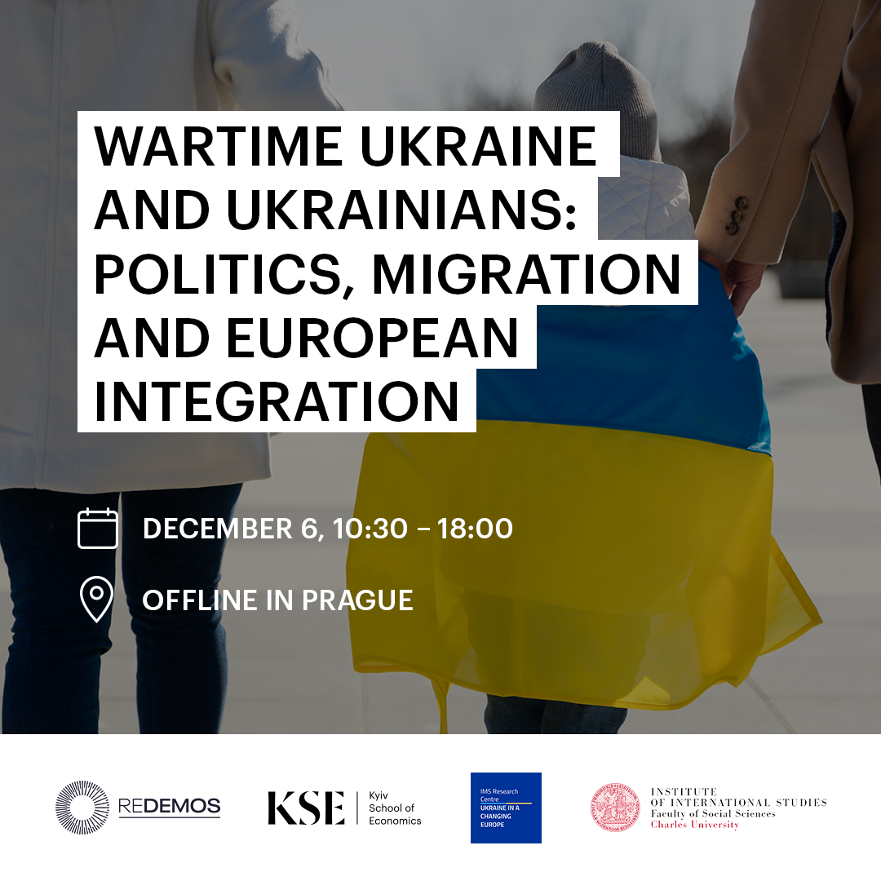
Kyiv School of Economics and the “Ukraine in a Changing Europe” Research Centre at Charles University in the framework of the REDEMOS project will hold a roundtable discussion "Wartime Ukraine and Ukrainians: Politics, Migration, and European integration" in Prague on December 6.
Russia’s shift to open and full-scale aggression raised the stakes and posed numerous challenges to Ukraine and Europe. The process of Ukraine’s post-Euromaidan development over the last 10 years has thus combined resistance to Russia’s aggression, internal reforms, and the assertion of Ukraine’s agency in the international arena.
How can Ukraine as a country under attack win an asymmetric yet existential war against a nuclear autocracy? What should be done to preserve and strengthen Ukraine’s democracy, so that the country’s post-war rebuilding takes places in a democratic and inclusive manner? What will incentivize Ukrainians abroad to return to the country? What key challenges will the EU-Ukraine enlargement negotiations face? And which experiences can the EU and Ukraine draw from the Union’s previous waves of enlargement and its engagement with the Western Balkans?
We invite you to join the discussion in Prague.
Venue: Smetanovo nabreži 6, Hollar building, Prague 1, auditorium H212
Faculty of Social Sciences, Charles University

Programme
10.30-11.00 – Introductory notes
Prof. Tomáš Weiss, Deputy Director for Research, Institute of International Studies, Charles University;
Dr. Valeria Korablyova, Assistant Professor and Leader of the “Ukraine in a Changing Europe” Research Centre at Charles University, Institute of International Studies;
Dr. Maryna Rabinovych, Assistant Professor at Kyiv School of Economics and Coordinator of REDEMOS project [Reconfiguring EU Democracy Support Towards a Sustained Demos in the EU’s Eastern Neighbourhood].

11.00-12.30 – Session 1. Democracy state-wide and locally

Dr. Valeria Korablyova, Assistant Professor and Leader of the “Ukraine in a Changing Europe” Research Centre at Charles University, Institute of International Studies;
Dr. Ivan Gomza, Associate Professor and Academic Director of the Public Policy Program (online participation);
Dr. Oleksandra Keudel, Assistant Professor at the KSE and Visiting Researcher at the Södertörn University in Sweden;
Prof. Olga Kutsenko, Professor of Sociology at KNU and Visiting Professor at the Technical University of Berlin;
Moderator: Maryna Rabinovych

12.30-14.00 – Lunch break

14.00-15.45 – Session 2. Ukrainians fleeing the war and their prospective reintegration: perspectives from Europe and beyond

Prof. Viktoria Sereda, 2022/2023 Senior Fellow at the Forum Transregionale Studien and Director of the project “Prisma Ukraïna: War, Migration and Memory”, Senior Researcher, National Academy of Science, Ukraine, Professor, Department of Sociology, Ukrainian Catholic University;
Dr. Olga Oleinikova, Senior Lecturer and Director of the SITADHub (Social Impact Technologies and Ukraine Democracy Research Hub) in the School of Communication at the University of Technology Sydney, Australia;
Kostiantyn Fedorenko, PhD researcher at ZoIS (Berlin, Germany);
Dr. Yana Leontiyeva, Head of department, Research Fellow at the Czech Social Science Data Archive, Institute of Sociology of the Czech Academy of Sciences;
Dr. Iryna Fyschuk, Scholars at Risk Fellow at the University of Agder (Norway);
Moderator: Valeria Korablyova

16.15-17.45 – Session 3. Ukraine’s European integration during the war

Dr. Maryna Rabinovych, Assistant Professor at Kyiv School of Economics and Coordinator of the Horizon Europe REDEMOS project;
Dr. Milada Anna Vachudova, Associate Professor of Political Science at the University of North Carolina, Chapel Hill III (online participation);
Dr. Andriy Tyushka, Senior Research Fellow at the European Neighbourhood Policy Chair (Natolin campus), College of Europe.

