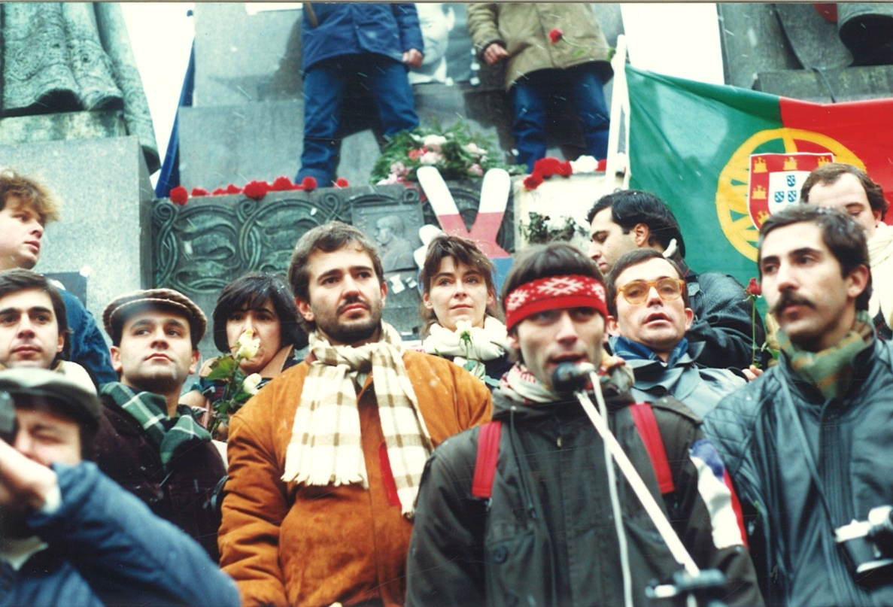

### December 10, 2019, 19:00

### room no. 212 (Hollar building)

The Institute of International Studies cordially invites you to take part in a discussion with Portuguese participants of Prague demonstrations in December 1989.

As the space is limited, we kindly ask you to register at:

**portugal-and-velvet-revolution@email.cz**

# Roses for Democracy:

# 30 years of Portuguese Solidarity with the Velvet Revolution